Created by Dr. Zoltán Subecz. John von Neumann University, Kecskemét, GAMF Faculty of Engineering and Computer Science, Informatics Department
subecz.zoltan@nje.hu

Internet-Hosting-Provider-PHP-Hungarian Nethely.hu-in English-2025-03

Presentation of usage at the free Internet hosting provider nethely.hu.

Nethely.hu: free, ad-free, 256 Mb storage with no time limit.
256 Mb: not enough for big sites, but good for small sites and learning.
No time limit if used regularly:
there is ad-free hosting where they give 2 Gb, but after 1 year the site is unavailable.

https://www.nethely.hu/
https://www.nethely.hu/tudasbazis

1. Start 2
Registration 2
Account authentication 2
Get started with free hosting 2
Turn on free storage 2
Select free domain 3
Domain connection 3
Create web address 3
2. Using FTP (File Transfer Protocol) 3
Uploading files with FTP 4
With Total Commander 5
With WinScp 5
Upload test.txt file 6
3. Database usage 6
Database access - Start phpMyAdmin 7
4. Simple PHP exercise with database 7

1. Start

Registration

email: …..
password

Confirmation of registration with the received email.

Account authentication

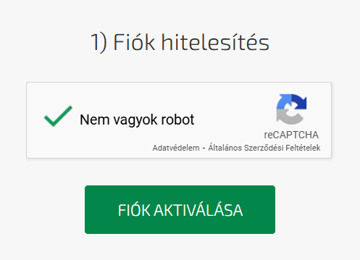

Get started with free hosting

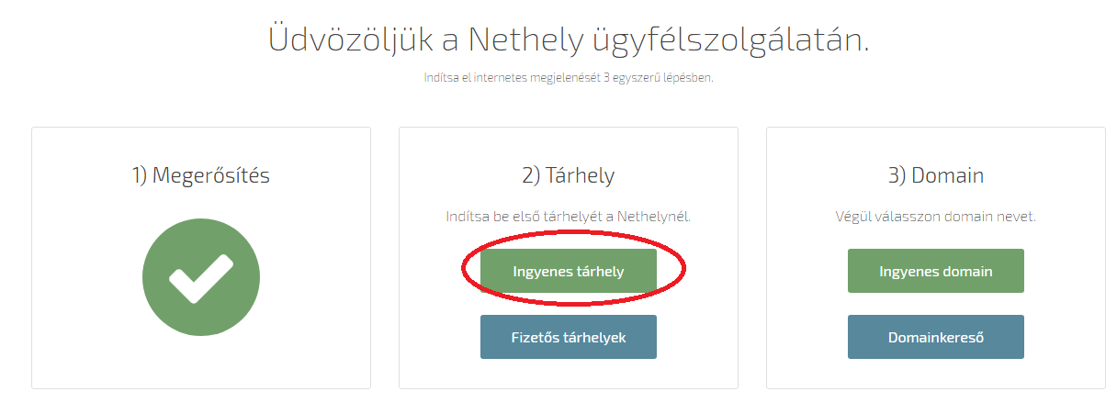

Turn on free storage

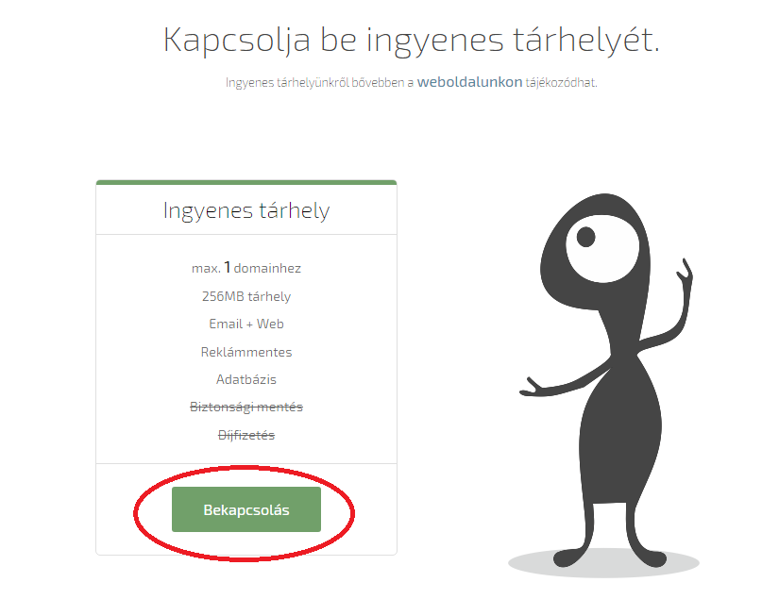

Select free domain

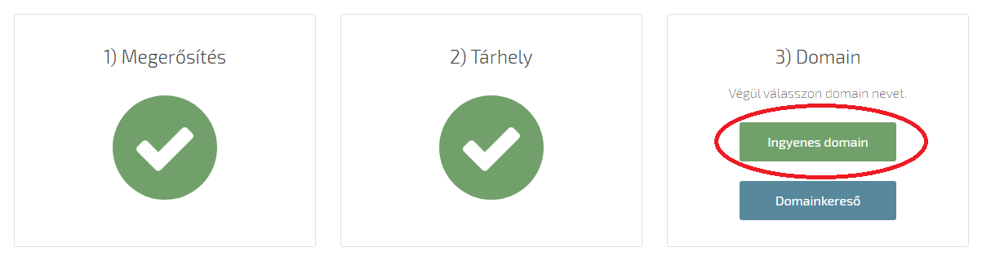

I chose this as my domain: gamf1.nhely.hu

Domain connection

Az Ön tárhelyei / Új domain csatolás
A létrehozott domain kiválasztása / Mentés
Your hostings / New domain connection
Select the created domain / Save

Create web address

Webcím létrehozása / Új webcím létrehozása
Nem kell elé előtagot beírni: maradjon az eredeti
PHP verzó: 8
Mentés
Create web address / Create a new web address
There is no need to enter a prefix: keep the original
PHP version: 8
Save

2. Using FTP (File Transfer Protocol)

https://www.nethely.hu/tudasbazis/ftp-letrehozas

FTP => Új FTP hozzáférés létrehozás
Create a new FTP access

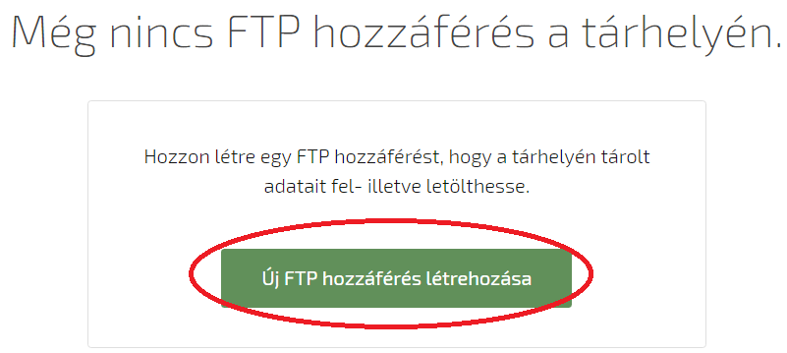

Here you choose a username (Felhasználónév) and password (Jelszó) to use FTP:
You should choose FTP/SFTP as the protocol. So you will be able to log in with FTP and SFTP.

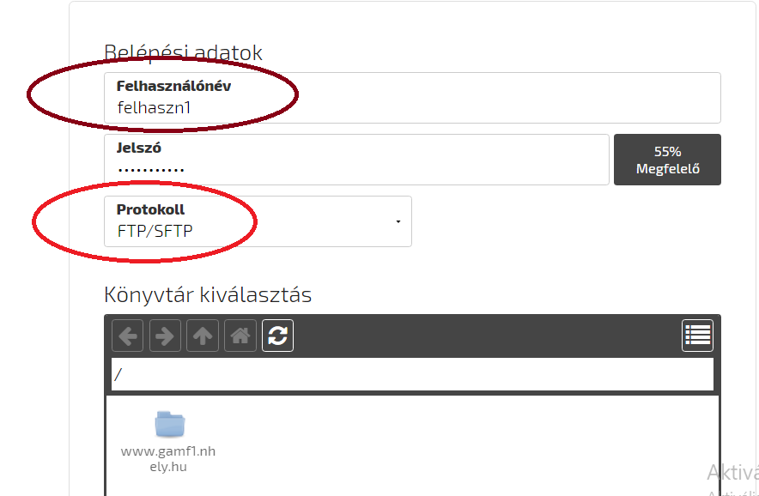

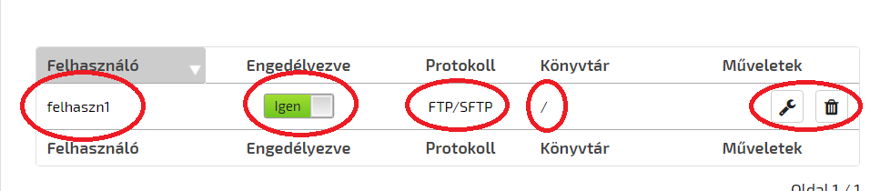

Uploading files with FTP

There are several free FTP clients. E.g. Total Commander client, WinScp, …
With the data set on the storage.

With Total Commander

https://www.nethely.hu/tudasbazis/ftp-total-commanderrel

One option:
By clicking the URL button:

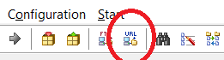

Or: Net menu / FTP new connection

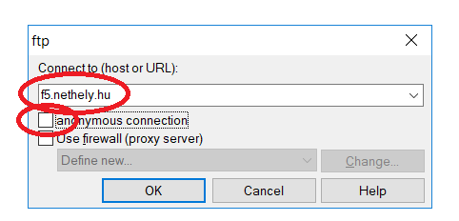

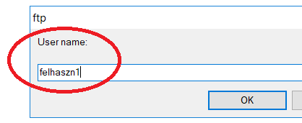

then give password

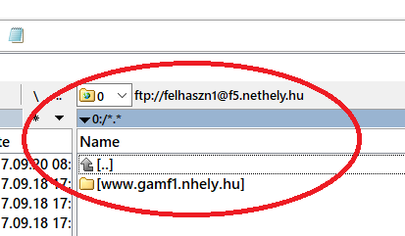

With WinScp

https://www.nethely.hu/tudasbazis/sftp-winscp

https://winscp.net/eng/download.php
Download portable version:
https://winscp.net/download/WinSCP-5.11.1-Portable.zip

After unpacking and starting:
If SFTP doesn’t work, choose FTP:

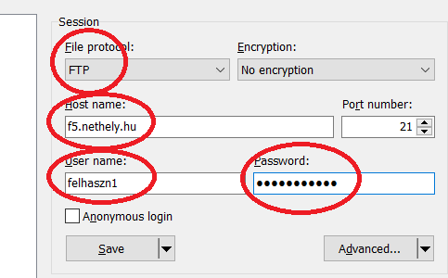

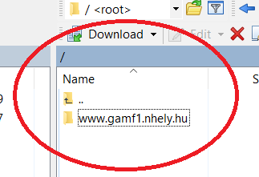

Upload test.txt file

Write only a simple text in the file: Hello
Copy the file to your main folder here: www.*****.nhely.hu

Böngésző címsorába:
www.*******.nhely.hu/test.txt
=> Hello

3. Database usage

Adatbázis / Új SQL adatbázis létrehozása
Database / Create a new SQL database

https://www.nethely.hu/tudasbazis/adatbazis-letrehozasa

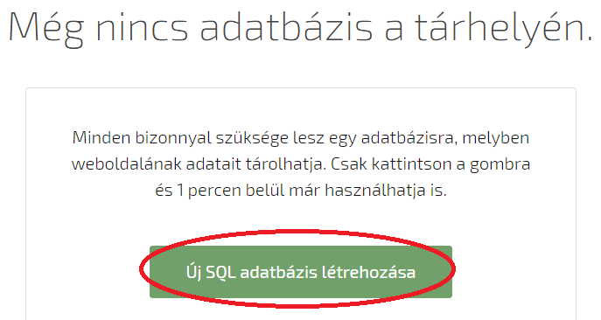

Choose a database name, e.g. datab1
and a password.
With the free version, we can only have one database.
With paid hosting, you can create several databases.

Remote access is not available on this hosting.
The public remote phpMyAdmin function is not available on this hosting.

Save

Approx you have to wait 1 minute until the database is ready.
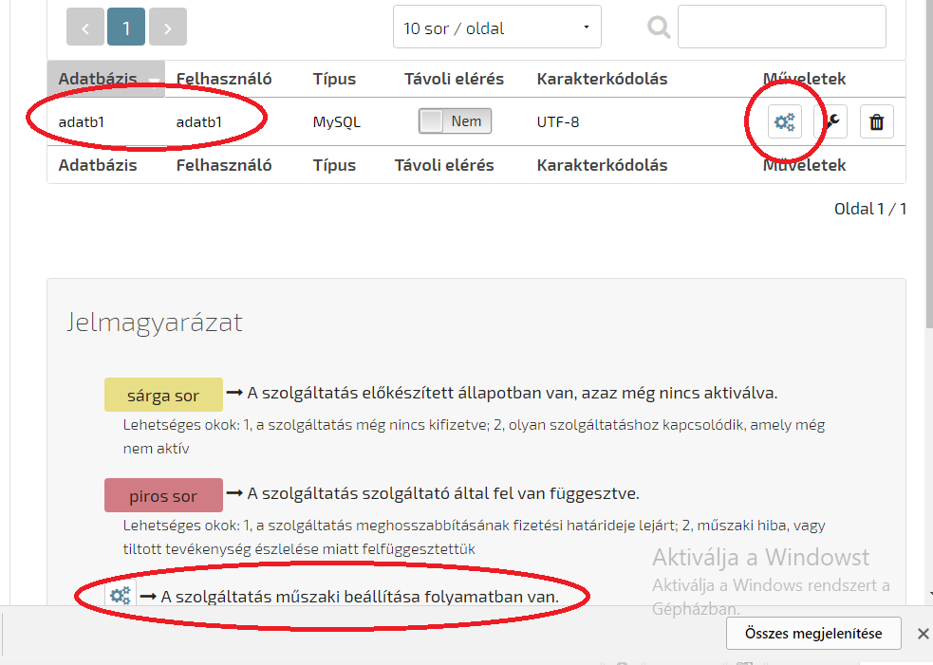

Database access - Start phpMyAdmin

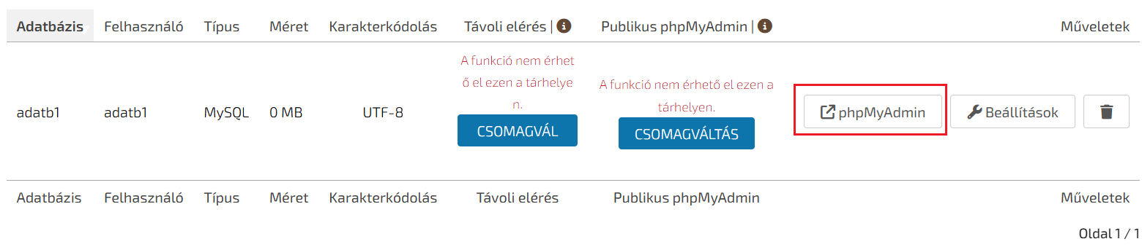

Clicking on phpMyAdmin button opens the phpMyAdmin management interface.

4. Simple PHP exercise with database

Create the next table in the database with phpMyAdmin:

CREATE TABLE users (
name varchar(45),
age int
);

INSERT INTO users (name,age) VALUES
('Name_1',25),
('Name_2',30),
('Name_3',40);

The red variables should be set according to the settings:

testDB.php
<?php
try {
$pdo = new PDO('mysql:host=localhost;dbname=dbname', 'DBusername','password',array(PDO::ATTR_ERRMODE=>PDO::ERRMODE_EXCEPTION));
$statement = "Select name, age From users Where age<35";
$result = $pdo->query($statement);
foreach ($result as $row)
print $row['name'] . " " .$row['age'] . "<br>";
}
catch (PDOException $e) {
echo "Error: ".$e->getMessage();
}
?>

http://gamf.nhely.hu/testDB.php
Name_1 25
Name_2 30

